Garden House CONCEPT BRIEF
• Interior design — key idea: Make all three spaces feel like one large house within a garden; the landscape is essential to this connection.
• Trisara alignment: More service-oriented, with a customer journey crafted naturally, without an obvious sales intention at the start.
• Lotus Gallery - Jewelry focus: Lead with jewelry first, then position La Prairie as jewelry-inspired products — e.g. Gold Radiance, Cellular Platinum, White Caviar Perk Infusion. Framing now leads with jewelry; CLP / La Prairie wording left for revision.
• Lotus Gallery potential: With the right setting and invitation strategy, it can perform like the private shopping salon of a luxury fashion brand — guests feel they are entering an exclusive space, and purchasing becomes a natural part of the experience.
• Little Garden: Link the space more strongly to the garden.
• Local art: Incorporate local art.

Lotus Gallery CONCEPT BRIEF

Purpose
Lotus Gallery serves as the jewelry, beauty, wellness, and lifestyle discovery space within the Garden House, a Trisara space.
Its primary role is to introduce guests to selected products, services, and experiences from the PATAMA ecosystem through personalized consultation and curated retail experiences rather than traditional retail selling.

Core Functions
- Present fine jewelry as the gallery’s signature focus, alongside selected fashion accessories, books, home objects, and lifestyle products
- Showcase local art and artisanal craft that reflect Phuket and Thai creativity
- Showcase Clinique La Prairie and La Prairie skincare collections
- Provide wellness and longevity consultations
- Introduce PATAMA Membership, CLP Phuket, and Tri Vananda through personalized conversations
Create meaningful one-to-one interactions that build trust and long-term relationships

Concept

A Luxury Jewelry, Personal Shopping & Wellness Salon
Rather than a conventional retail store, Lotus Gallery is envisioned as an intimate and highly curated environment where guests can explore beauty, wellbeing, and meaningful living through personalized recommendations.
Inspired by the experience of a luxury private shopping salon, the space combines wellness consultation, product discovery, and lifestyle inspiration within a calm and elegant setting.
Only a carefully selected collection of products and experiences will be displayed, ensuring the space feels curated, residential, and refined rather than commercial.

Design Direction
The space should feel:
- Elegant yet approachable
- Residential rather than retail
- Calm, feminine, and timeless
- Curated rather than merchandise-driven
- Luxury without excess
The design can be intentionally minimal, allowing products, materials, and conversations to become the focal points.
Key elements may include:
- Fine jewelry showcase and collectible vitrines as a focal display
- Local art and artisanal craft display
- Consultation table for private conversations
- Curated display shelves and vitrines
- Product testing and discovery area
- Comfortable lounge seating
Fresh flowers and botanical elements inspired by the lotus

Design Reference Note
The reference images provided are intended to illustrate the functional intent, atmosphere, and guest experience of the space only. They should not be interpreted as a direct design direction for Lotus Gallery.

Guest Experience
Guests may discover Lotus Gallery through their journey within the Garden House.
A guest might begin with a coffee or cocktail in the Living Room, spend time with family at Little Garden, and naturally enter Lotus Gallery to explore skincare, wellness programs, jewelry, or lifestyle products.
The objective is not immediate sales, but to inspire curiosity, build trust, and create deeper engagement with the PATAMA ecosystem.

Reference Images
Illustrative precedents grouped by functional intent. As noted above, these convey atmosphere and guest experience only — not a literal design direction.

Personal Shopping
Intimate salon, consultation and lounge settings — where discovery happens through conversation and comfort.
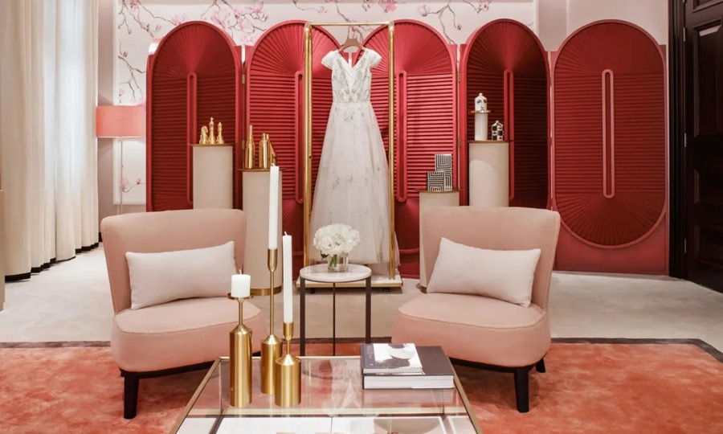
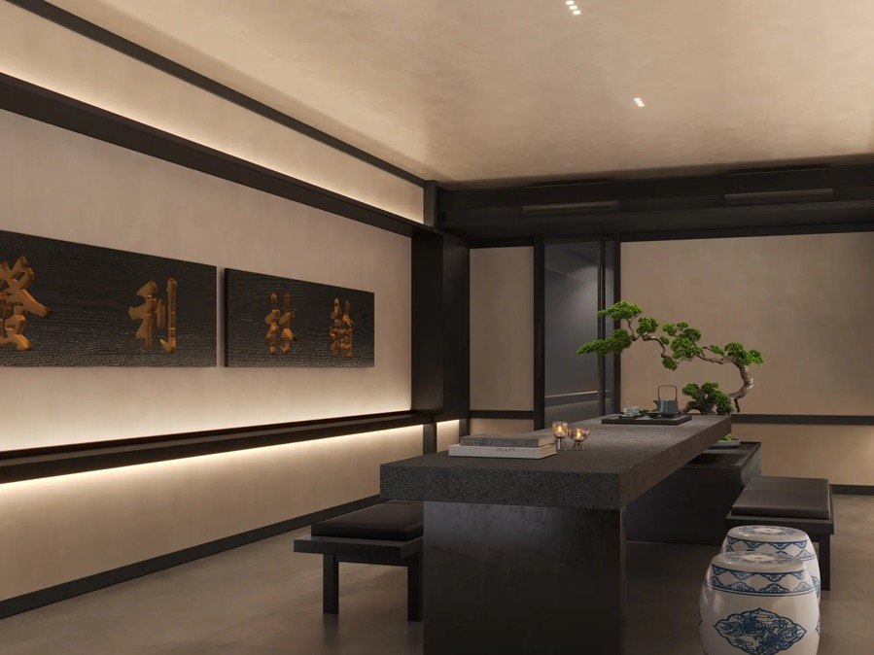
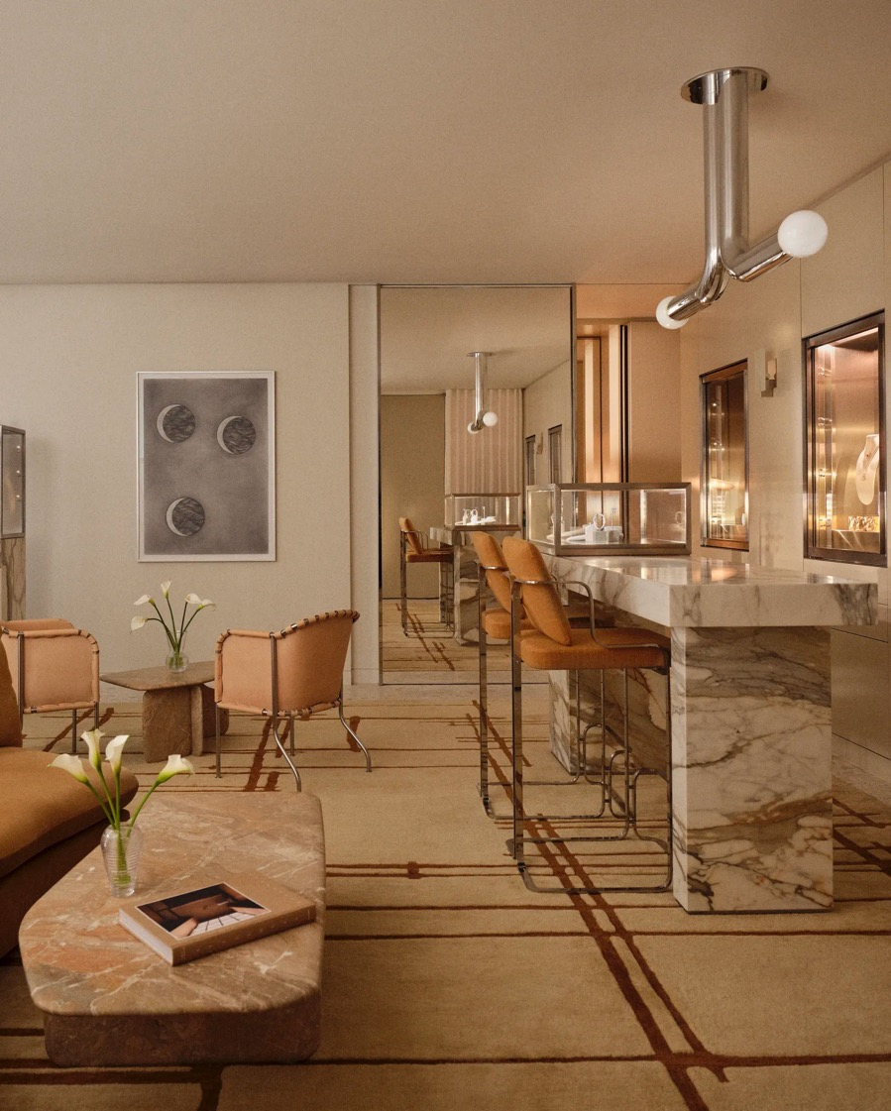
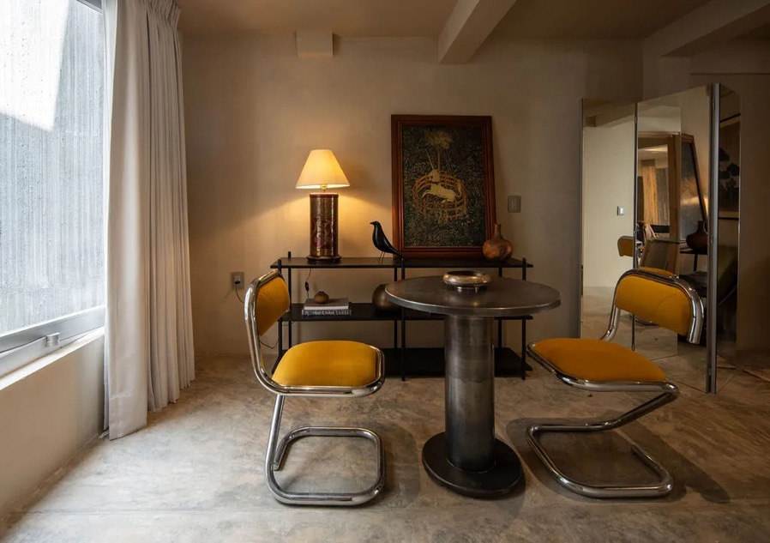
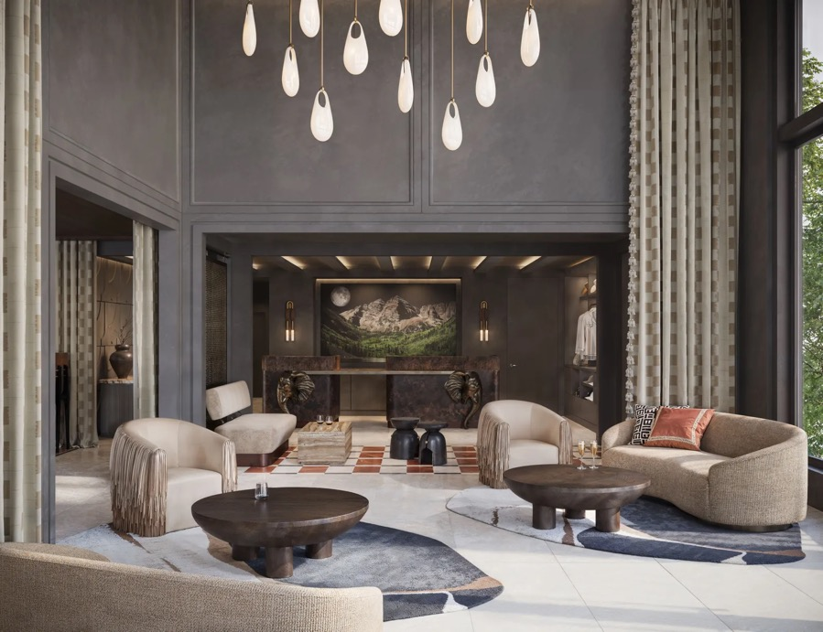
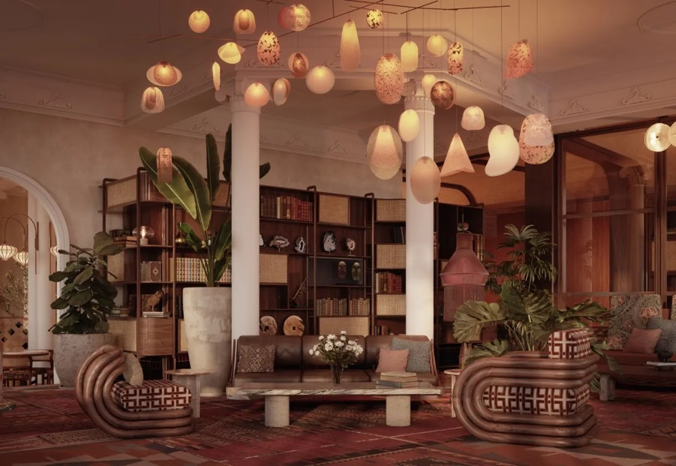
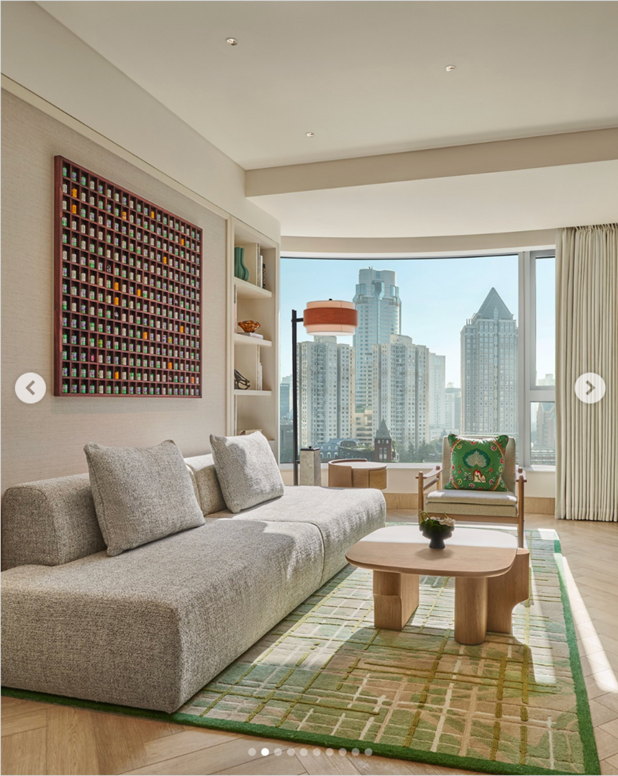

Minimal Retails
Restrained retail counters, vitrines and curated display — products presented sparingly, never merchandised.
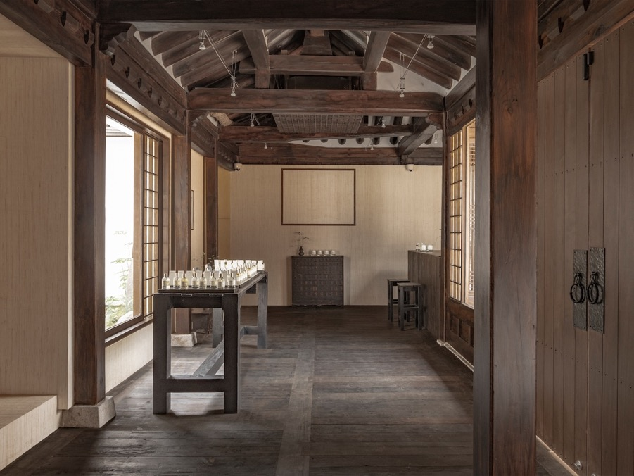
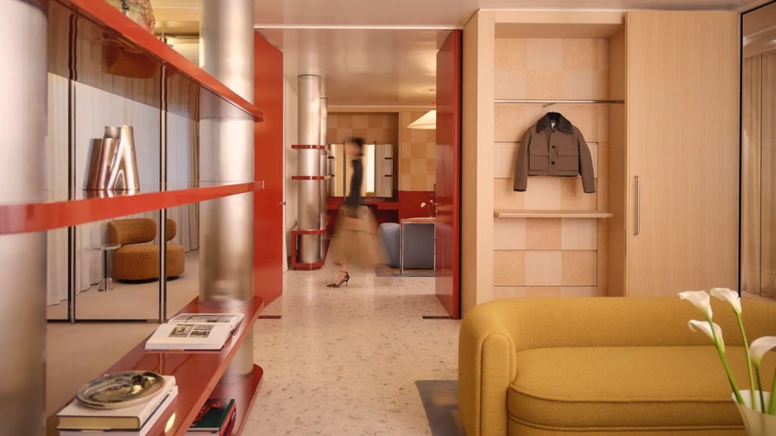
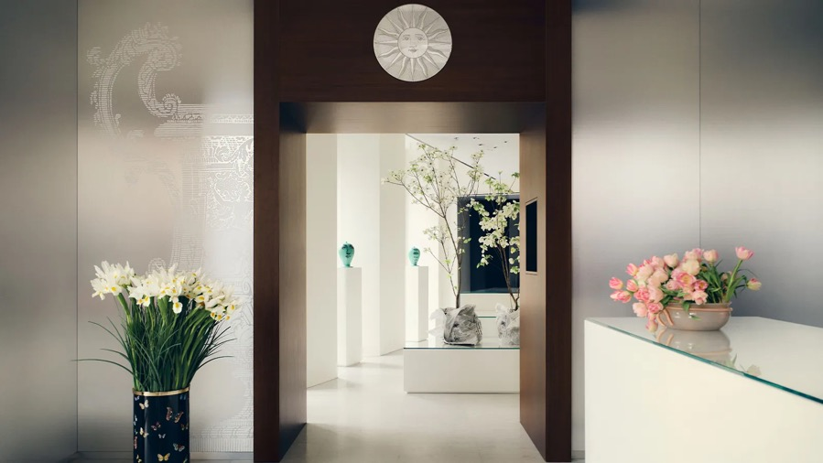
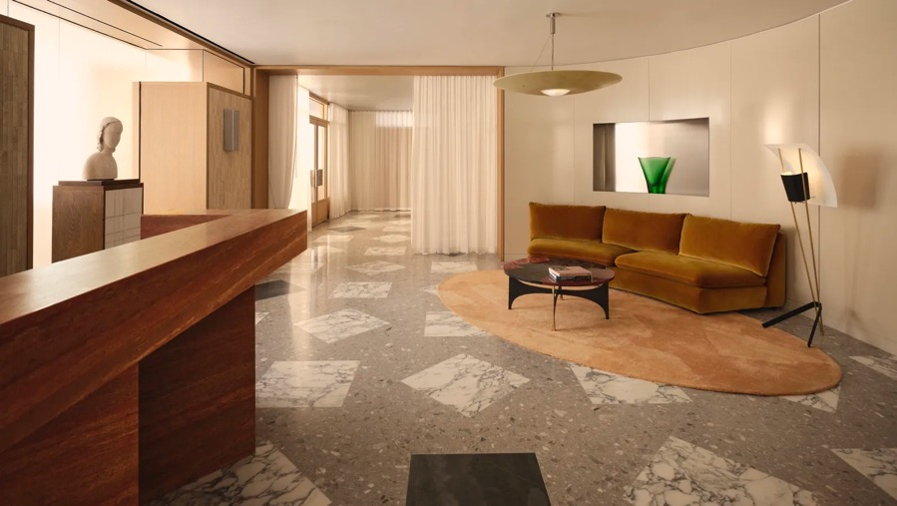
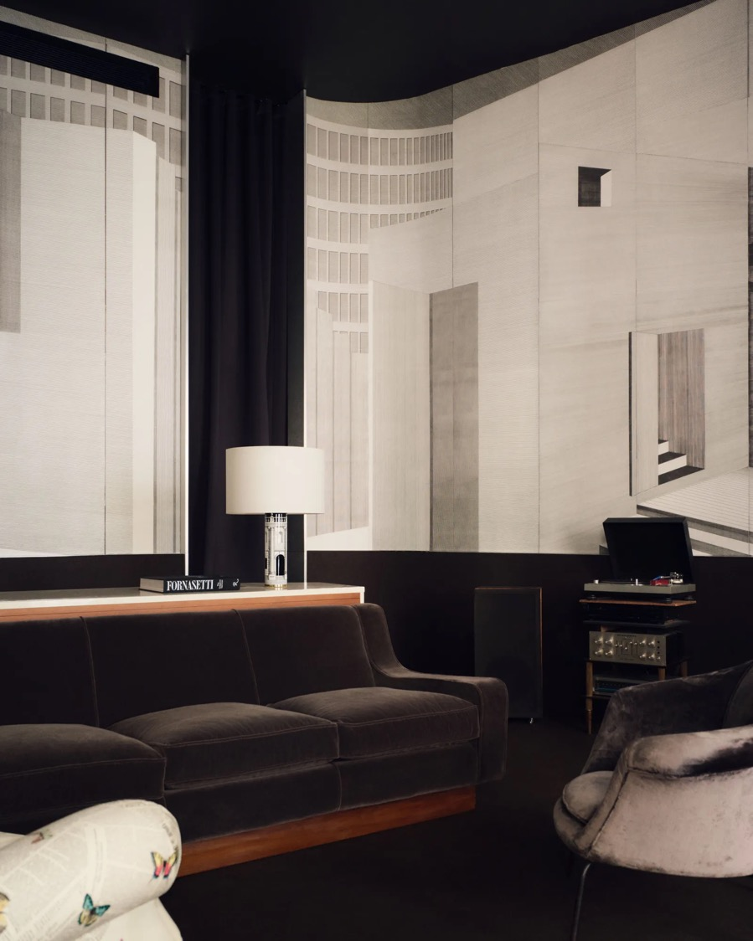
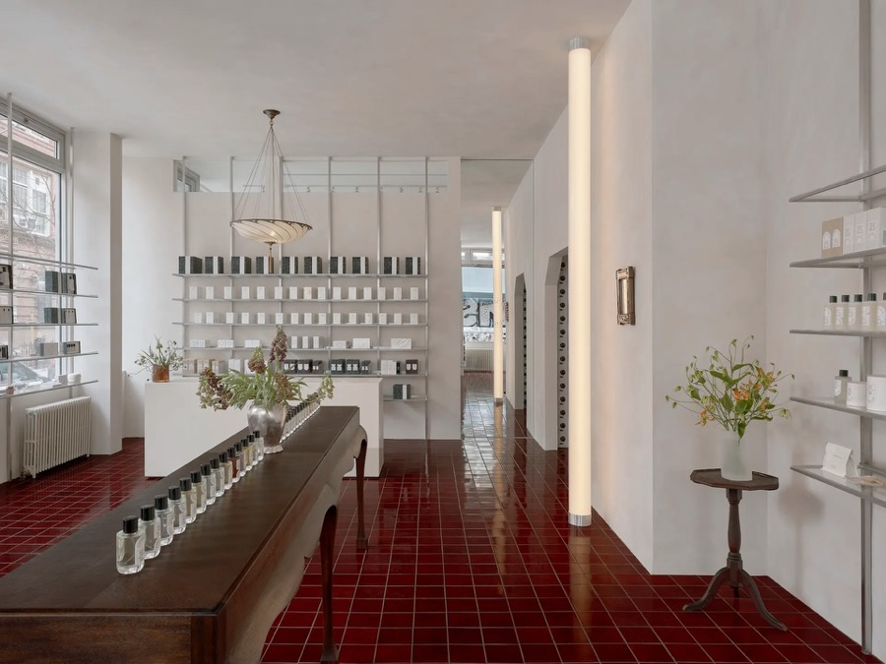
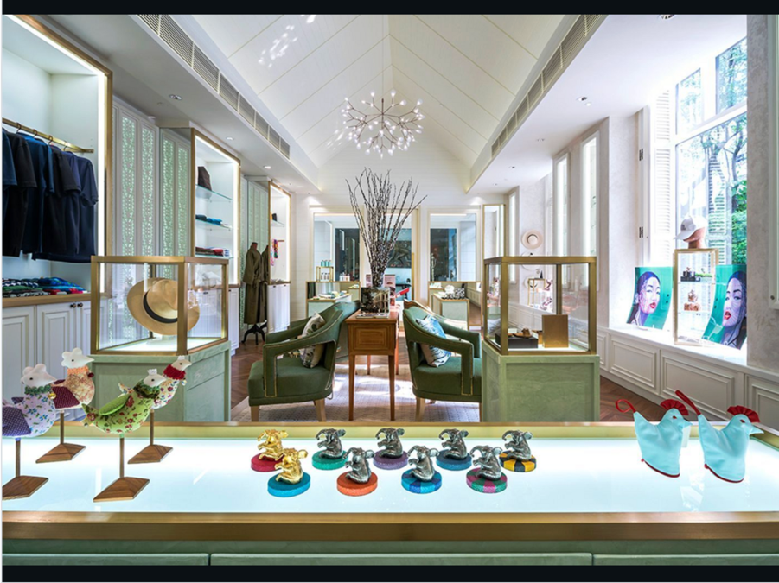

Materials & Atmosphere
Material and architectural details — cabinetry, marble, mirror and ceiling treatments that set the atmosphere.
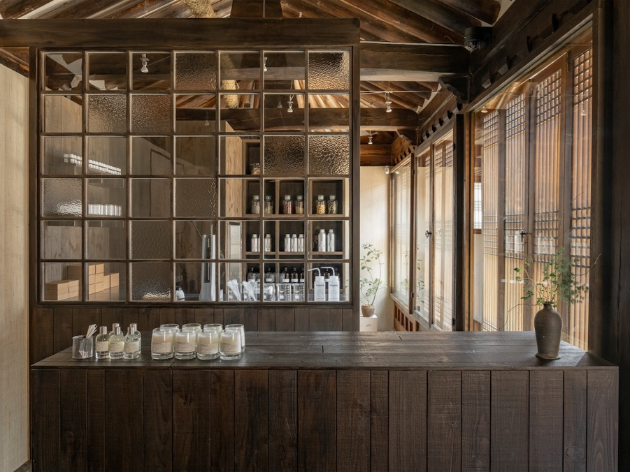
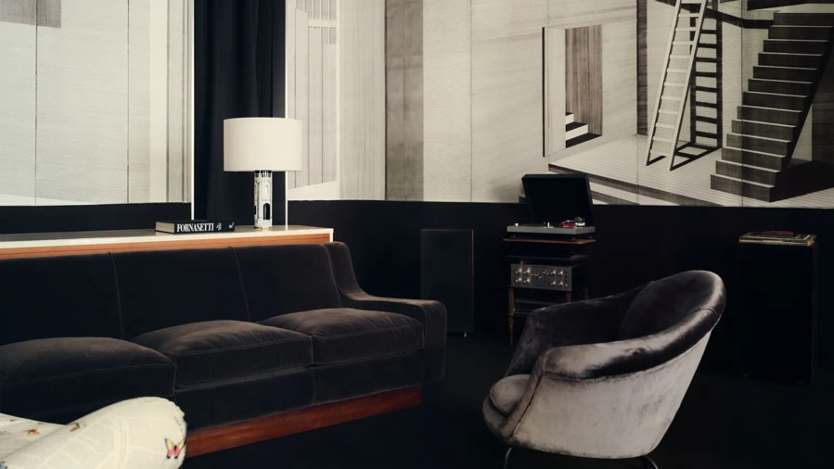
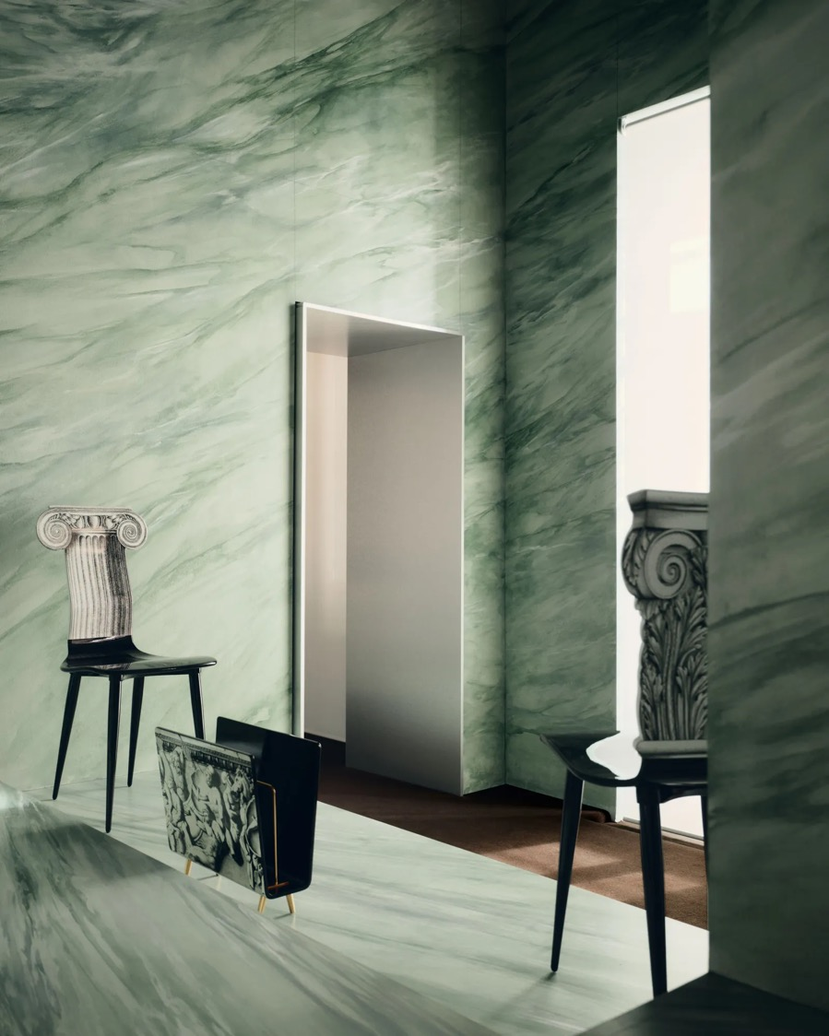
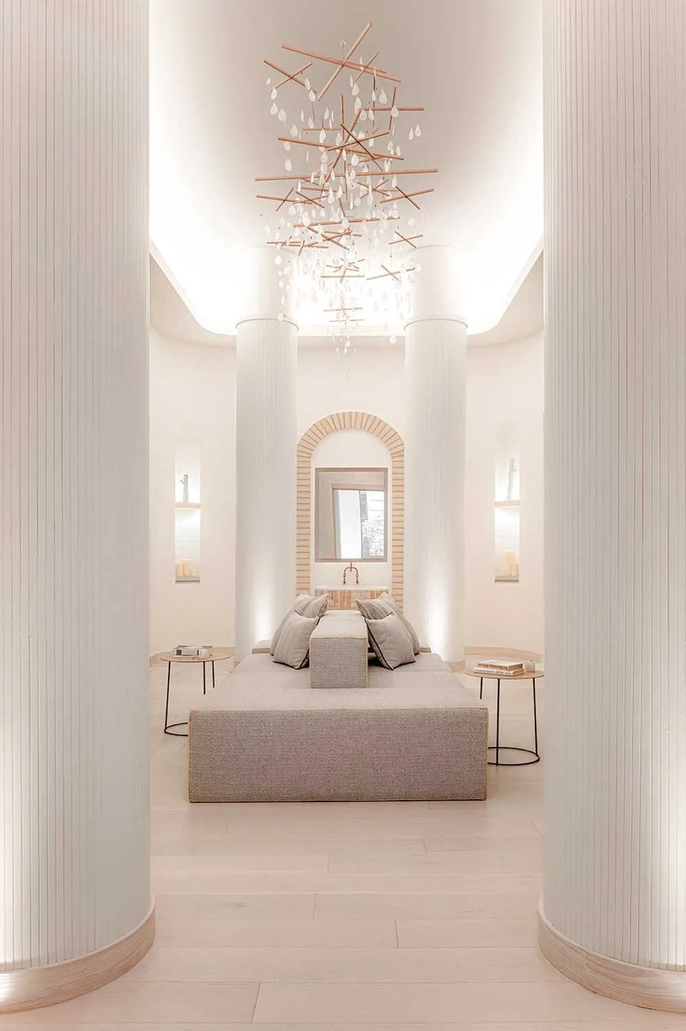
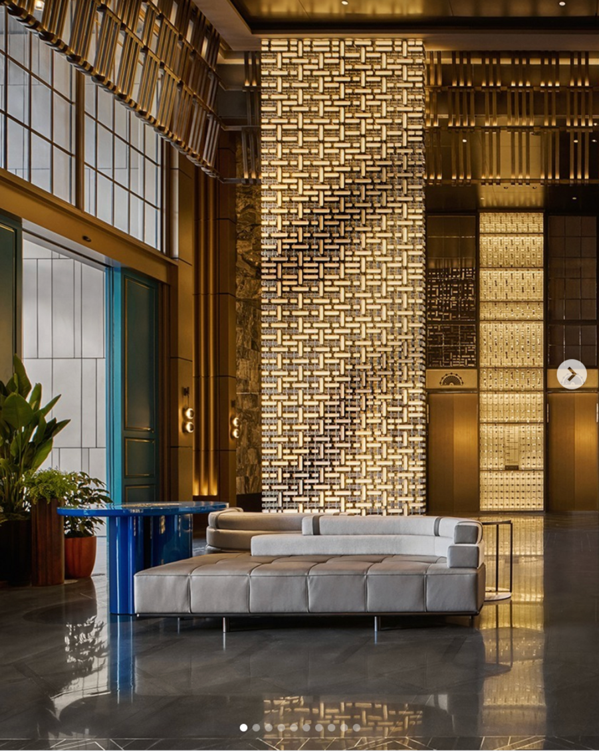
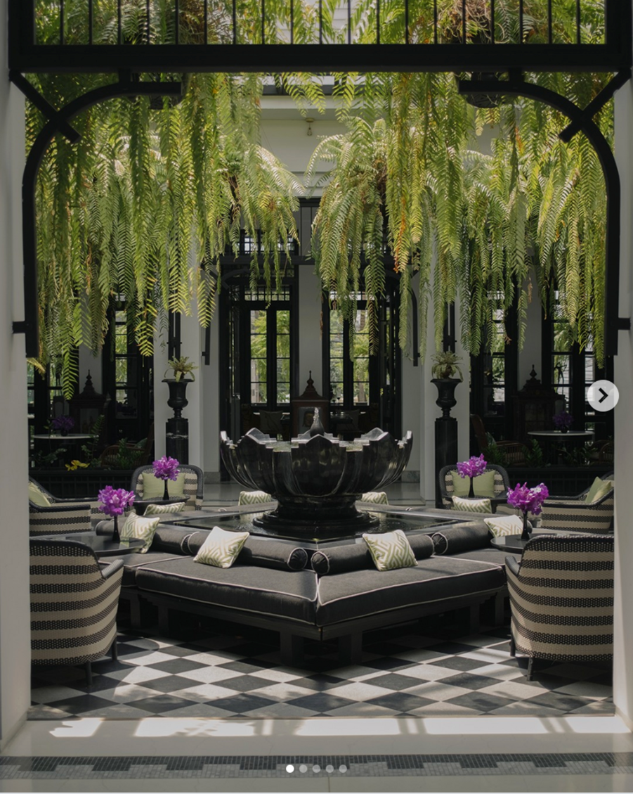

Local Art & Craft
Thai and Phuket artistry — murals, sculptural pieces and curated objects that root the space in place and culture.
